Enterprise Zone Incentives & Programs
2025
Patrick County is proud to offer a number of local incentives under the Enterprise Zone program through our Economic Development Authority (EDA). Any business located within Patrick County’s uniquely large (3700+ acres) Enterprise Zone is eligible to qualify for one or more of our local incentives.
Machine & Tools Tax Grant
Any commercial or industrial company that purchases new manufacturing equipment may be eligible for our M&T grant. All new companies starting in or relocating to Patrick County can receive up to 100% of taxes paid on new equipment in Year 1, 75% in Year 2, and 50% in Year 3. Existing companies can receive the M&T grant if the new equipment value is greater than 10% of the total value of existing equipment from the previous year.
Rehabilitated Real Estate Tax Exemption
An exemption on the increase in real estate tax assessment caused by rehabilitation, renovation, or replacement of business facilities 15 years or older of 100% in Year 1, 50% in Year 2, and 25% in Year 3. Limited to commercial/retail/industrial facilities of age 15 years or more. Must invest at least 10% of pre-project building assessment.
Transfer Station Tipping Fee Reduction
A reduction of the tipping fee at the Patrick County Transfer Station on all non-hazardous debris from construction/renovation projects. Reduction of fee to County’s cost of having debris transferred out of County. Limited to non-hazardous construction/renovation debris associated with retail/commercial/industrial projects within the Patrick County Enterprise Zone.
Other Local Incentives
Accelerated Local Permitting; Below Market Value Sale of Economic Development Authority Land; Patrick Springs Water and Sewer Utility Extension; Rich Creek Corporate Park Development Initiative

Façade Grant Incentive Program

The Patrick County Economic Development Authority (EDA) funds and administers façade grants, which are available to qualifying commercial, industrial, and mixed-use developments in Patrick County.
Purpose of the Program
The EDA recognizes the merit and value of our businesses, which call our scenic County of Patrick home to their company and employees. This façade grant program aims to show our investment in our local business community and help make our buildings and establishments match the beautiful surroundings.
These grants will aid in continuous visual improvement within our communities, encourage investment and expansion, and decrease the number of vacant storefronts. The long-term impact of these façade grants will improve the overall business and tourism climate, improve the overall vibrancy, and serve as a true economic development foundation and tool for revitalizing Patrick County and Downtown/Uptown Stuart.

Grant Program Period
Only Ten (10) applications will be accepted/approved in one (1) fiscal year. The county's Fiscal year runs from July 1 to June 30. The Grant period will expire June 30, 2026.

Façade Grant Program Definitions
_____________________________________________________________________________________

Façade
This refers to the principal face or front of a building, which includes the main entrance to the business and looks at the street or public right-of-way (not including alleys).
Façade Renovation
Defined as restoring to a better state by repair. A building may have multiple façades should it be located on a street corner, whereby the two façades facing public streets may be included in a single façade grant application as one façade.
Application Process

1. Must complete and sign the application form (by the owner of record) and return it to the Patrick County Economic Development office prior to initiating work on the façade.
a. Exceptions may be granted for a project that requires demolition work to determine the scope of façade improvements, for investigatory purposes necessary in applying for Historic Tax Credits, or emergency structural purposes

2. The Economic Development Authority of Patrick County will review and approve or disapprove the application at its next regularly scheduled meeting based on eligible and ineligible costs (chart below).
a. The applicant or project representative must attend the EDA meeting in person to provide an overview or presentation of the proposed project and answer any questions from EDA members.
b. The applicant must receive all requisite approvals and permits from Patrick County and (depending on the location of the property) the Town of Stuart before presenting the project to the EDA.
c. The EDA meets on the fourth Wednesday of every month, and applications must be submitted for review no later than COB two weeks before the next meeting.

3. The EDA may require further descriptions, plans, sketches (etc.) of the project before making a final decision on the eligibility of the project
4. If the project qualifies and funds are available, a maximum of $5,000, or one-half (50%) of the total façade renovation construction cost, whichever is less per project, may be granted.
5. No soft costs (architectural, design, engineering, etc) will be considered as eligible reimbursable costs for any façade grant.
6. The EDA will reimburse grant funds only upon receiving verifiable receipts of construction costs, proof of payment, and a photograph or visit to the completed façade project.
7. The façade renovation must be completed within one year of approval unless the EDA grants an extension for such date.
8. Business owners may receive only one façade grant every ten years.
9. Applicants must comply with all applicable laws, rules, and regulations.
10. Applicants must submit paperwork for grant reimbursement to the Economic Development office no later than 90 days after the grant's expiration date, but they may also complete the work prior to the approved timeline requested.

Façade Grant Eligibility

Eligible Façade Improvement Ineligible Façade Improvement

- Awnings
- Demolition and removal of existing façade elements
- Doors and treatments
- Downspouts/Guttering
- Electrical work towards lighting on a façade for security and visual improvement
- Exterior finishes (brick, rock, stucco)
- Murals
- Permanent flood reduction features required by FEMA
- Painting
- Pressure-washing/sandblasting to restore elements
- Rental equipment (façade work only)
- Shutters
- Storefronts
- Windows and treatments
- Woodwork

- Blinds/curtains/shades
- Decking
- Dumpster rental
- Demolition/excavation work for separate work inside or other parts of larger project
- Fees (permitting, soft costs, etc.)
- Fencing
- Interior elements or projects
- Landscaping
- Parking lot repair or install
- Pedestrian flow control (barriers, rope, tape, etc.)
- Roofing
- Sidewalks
- Signage

Façade Grant Application
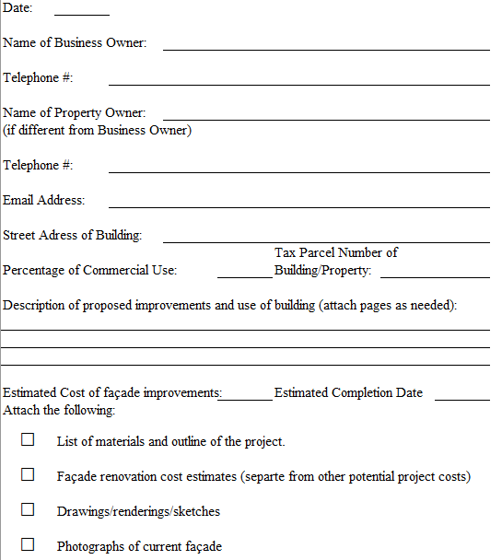

I understand that I must submit all documentation no later than 90 days after the completion date when the project is completed in order to receive the grant; construction contracts and/or receipts documenting investment in the façade of the building, photograph of the completed project, and such other documents as the EDA may request.
I understand that the Economic Development Authority must approve this application before work begins on the façade project, or I may not be eligible for this grant.
Signature of the applicant: ___________________________________________

If Applicable:
Agreement for Applicant to perform work as described above.

Signature of the Property Owner: ______________________________________
Return this application and all supporting documentation for review to the Patrick County Economic Development office, 106 Rucker St, Suite 218, Stuart, VA 24171, or fax 276-694-2160.

